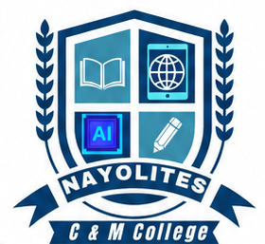 | NAYOLITES  COMPUTER AND MEDIA COLLEGE  — Empowering Skills. Creating Futures —  📍 Kisii Town, Kisii County, Kenya | 📞 0796410290 | ✉ nayolitesempire@gmail.com

FEE STRUCTURE
VIDEOGRAPHY COURSE

The following is the approved fee structure for the Certificate in Videography course at Nayolites Computer and Media College.
FEE ITEM | AMOUNT (KSH)
Admission Fee | 500
Tuition Fee | 6,000
Examination Fee | 2,000
Certification Fee | 2,500
TOTAL COURSE FEES | 11,000

The total cost for the Videography course is KSh 11,000, covering admission, tuition, examinations, and certification.  • Admission Fee .............. KSh 500  • Tuition Fee .............. KSh 6,000  • Examination Fee .......... KSh 2,000  • Certification Fee ........ KSh 2,500 | This Videography programme is designed to equip students with professional skills in camera operation, shot composition, lighting techniques, video production, storytelling, editing, motion graphics, and professional videography practices for events, documentaries, commercials, and digital media platforms.
  FEE SUMMARY
  GRAND TOTAL | KSh 11,000
  ABOUT THE COURSE

________________________________________  Principal  Nayolites Computer and Media College  Date: ____________________________________
  NAYOLITES COMPUTER AND MEDIA COLLEGE
  P.O BOX 1748-40200
  KISII.
  Date:.......... TEL: 0796410290

